**Ministry of Education and Training**



**HO CHI MINH UNIVERSITY OF TECHNOLOGY AND EDUCATION**

**FACULTY FOR HIGH QUALITY TRAINING**

**--------------------**



**PROJECT ON MOBILE PROGRAMMING**

**FOODY APP**

**INSTRUCTOR: *Truong Thi Ngoc Phuong***

**STUDENTS:**

***Trương Hoàng Ân 19110001***

***Nguyễn Tiến Hoàng Vũ 19110069***

**HO CHI MINH CITY – 2022**

CỘNG HÒA XÃ HỘI CHỦ NGHĨA VIỆT NAM

Độc lập – Tự do – Hạnh phúc

Ho Chi Minh City, May 18, 2022

**PROJECT CONTRIBUTION**

Full name: Trương Hoàng Ân ID: 19110001

Full name: Nguyễn Tiến Hoàng Vũ ID: 19110069

Major: Mobile Programming

Instructor: Truong Thi Ngoc Phuong

Date of getting topic: 07/04/2022 Submit date: 18/05/2022

1. Topic: Foody App

2. Original data and documents:

3. Contents:

4. Product:

**INSTRUCTOR**

Truong Thi Ngoc Phuong

Contents

**ACKNOWLEDGEMENT** 4

**CONTENT** 5

**I.** **DESIGN:** 5

**1.** **Applied knowledge:** 5

**II.** **THE FEATURES OF FOODY APP:** 5

**1.** **User Interface:** 6

**2.** **Login Screen:** 7

**3.** **Foody App main interface:** 9

**4.** **Add Location interface:** 15

**5.** **Payment history interface:** 17

**6.** **Your profile interface:** 18

**CONCLUSION** 23

**1.** **Achievements:** 23

**2.** **Advantages:** 23

**3.** **Inadequacies:** 23

**4.** **General harvest:** 23

**5.** **Task Distribution** 23

# **ACKNOWLEDGEMENT**

The success of a student more or less always accompanies a lecturer. We would like to express our sincere thanks to ***Mrs. Truong Thi Ngoc Phuong***, who directly supported the group, give us suggestions, comments and suggestions as well as provide tips to help us make the best project. Thanks to his instructions, helped our team understand the knowledge to do the presentation as well as the implementation of the project so we have completed the schedule with a lot of experience that we learn. Again, our team would like to thank the lecturer. Projects are made around two months, just enough to complete it. However, due to some unexpected problems the project will have many errors, that is inevitable.

Through the course, we have created a learning environment and learned how to build a real product to help us improve our personal skills and build a spirit of doing physical work.

Our team is looking forward to receiving your comments and suggestions to improve the topic more and more.

Sincerely thank!

Project implementation group.

Ho Chi Minh city, May 18, 2021

**Students**

**Vu - An**

# **CONTENT**

1. **DESIGN:**
2. **Applied knowledge:**

* Layout
* Event Handling
* List view
* SQLite
* Fragment
* Tab Layout
* View Pager

1. **THE FEATURES OF FOODY APP:**

### **User Interface:**

*Main login screen*

### **Login Screen:**

1. *Login with gmail:*

*Login with gmail*

1. *Notice when wrong login:*

*Notice when wrong login*

### **Foody App main interface:**

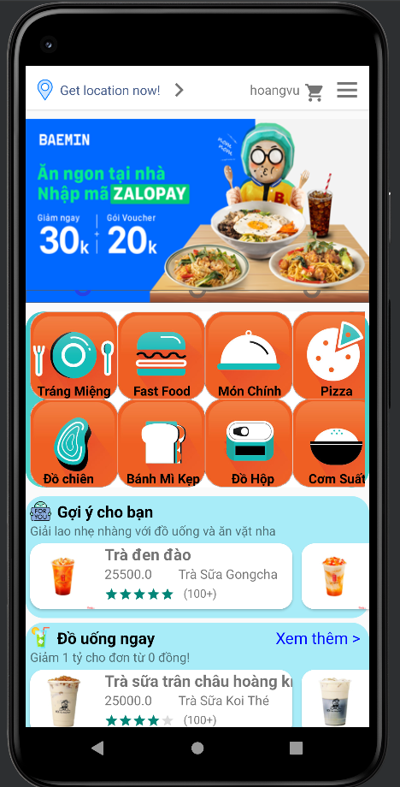

*Foody App main interface*

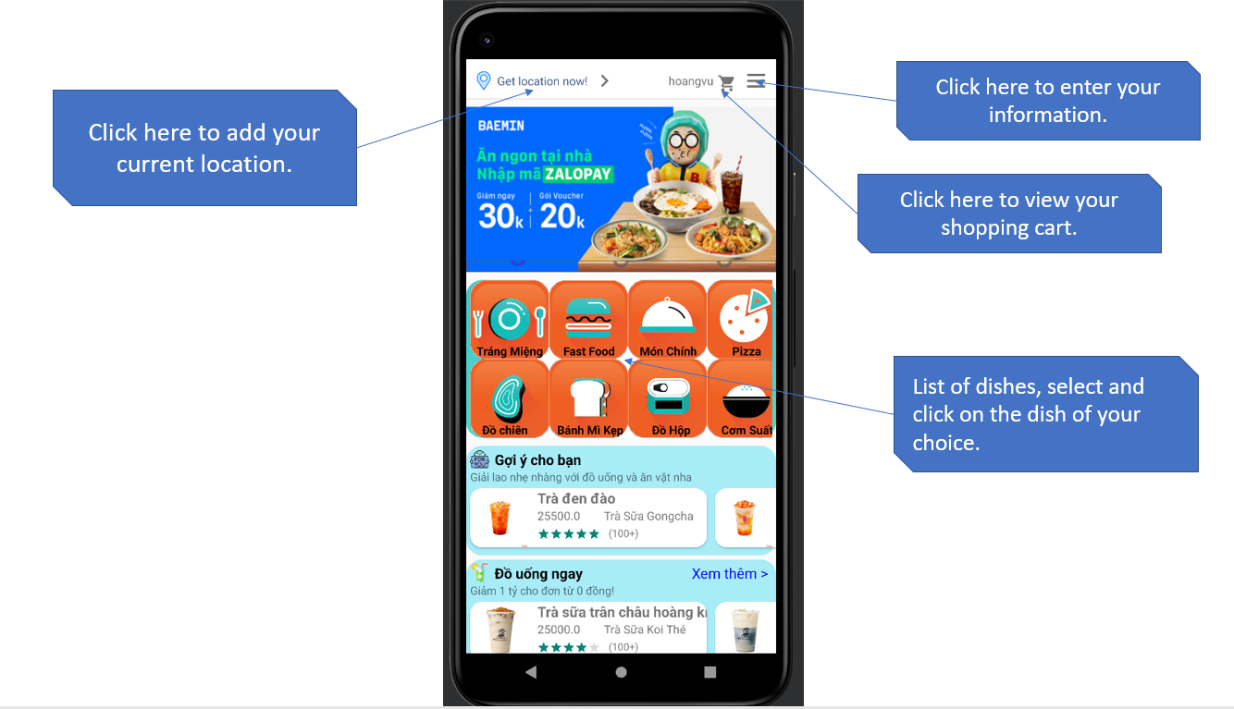

*Foody App main interface*

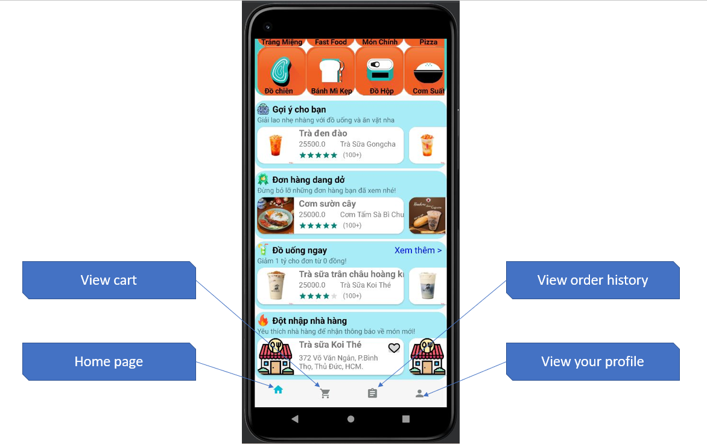

* 1. *Order:*

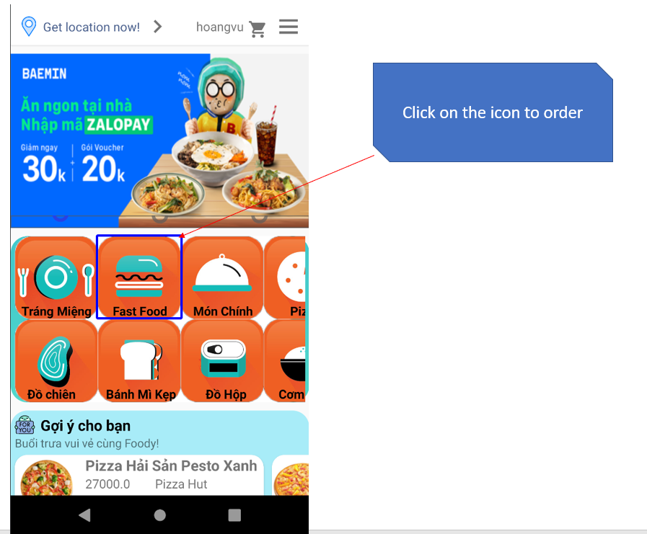

*Oder food*

* After choosing the dish above:

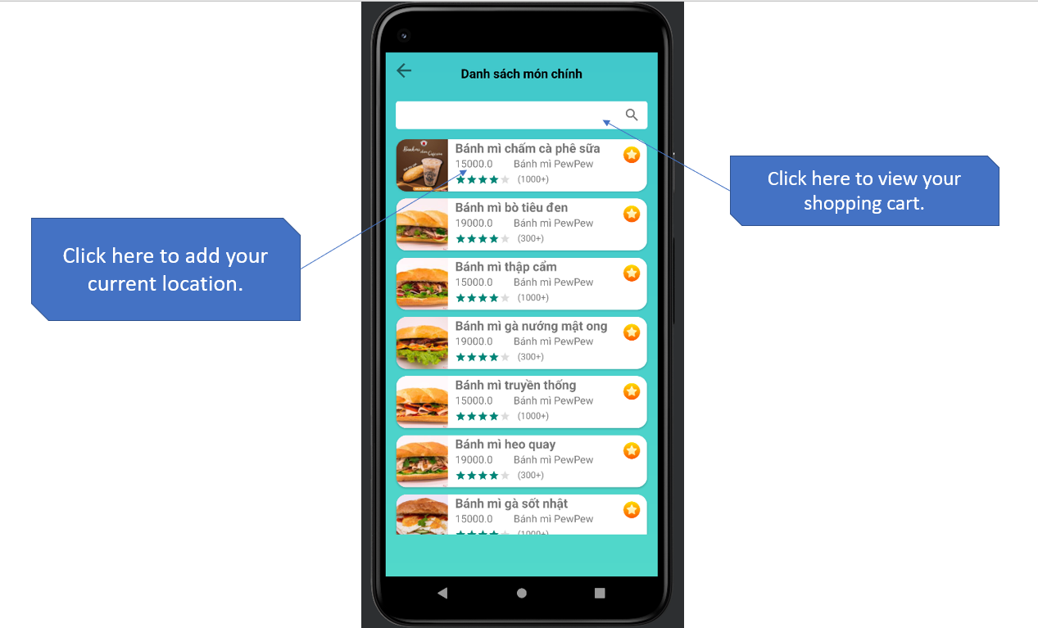

*Oder items*

* Order items interface:

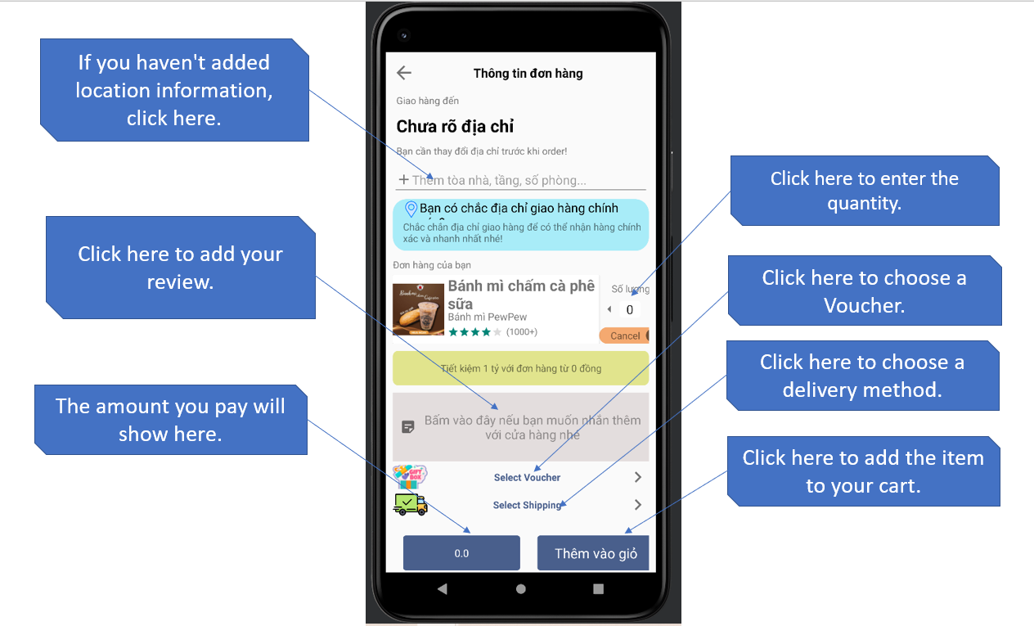

*Oder items*

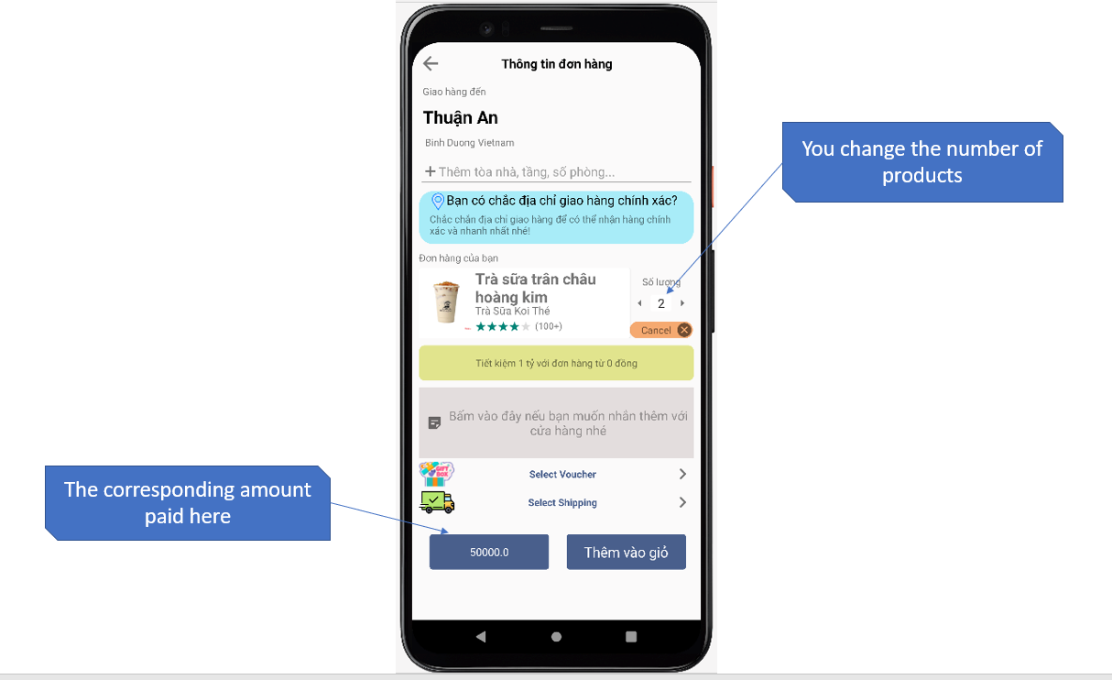

*Oder items*

* Notice of successful order:

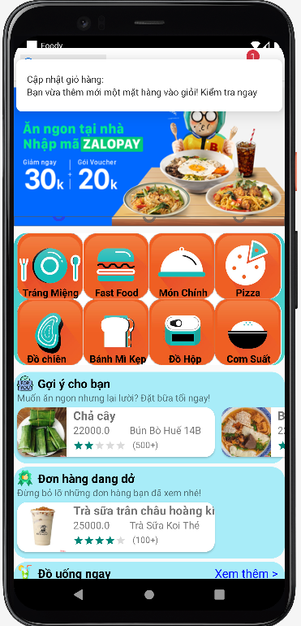

*Notice of successful order*

* List of items ordered:

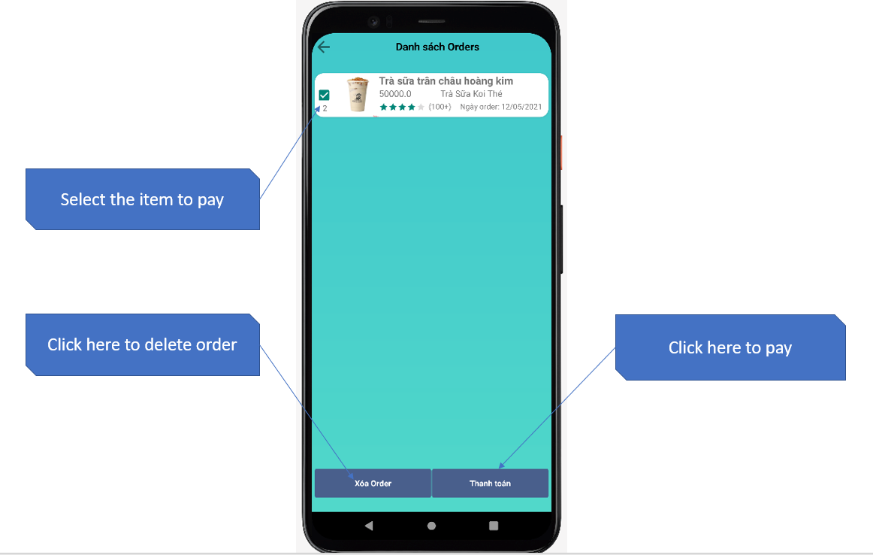

* 1. *Food suggestions:*

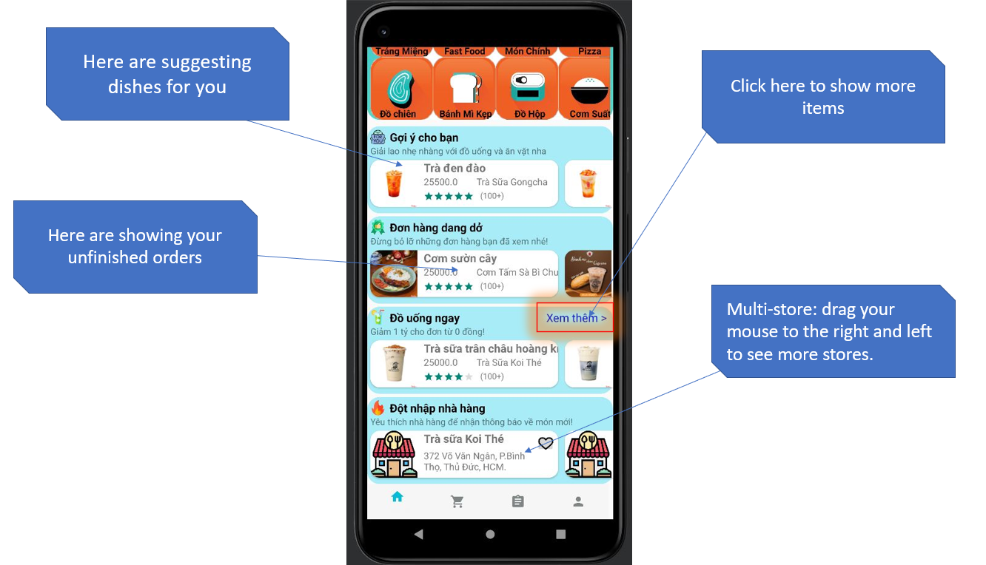

*Food suggestions*

*List meal in menu of some restaurants*

1. **Add Location interface:**

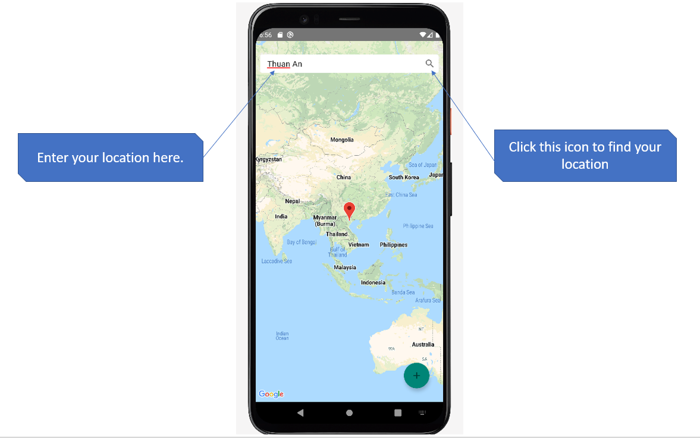

*Add location*

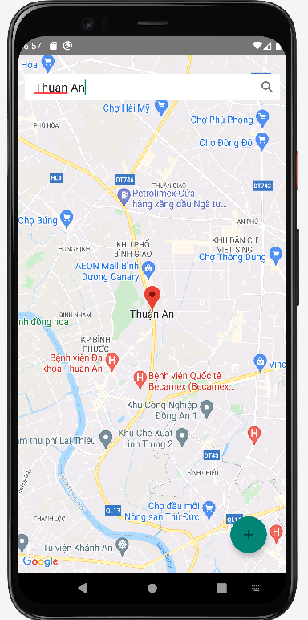

*Add location*

1. **Payment history interface:**

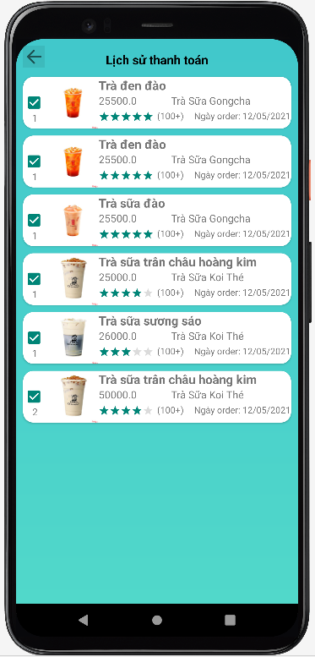

*Payment history*

1. **Your profile interface:**

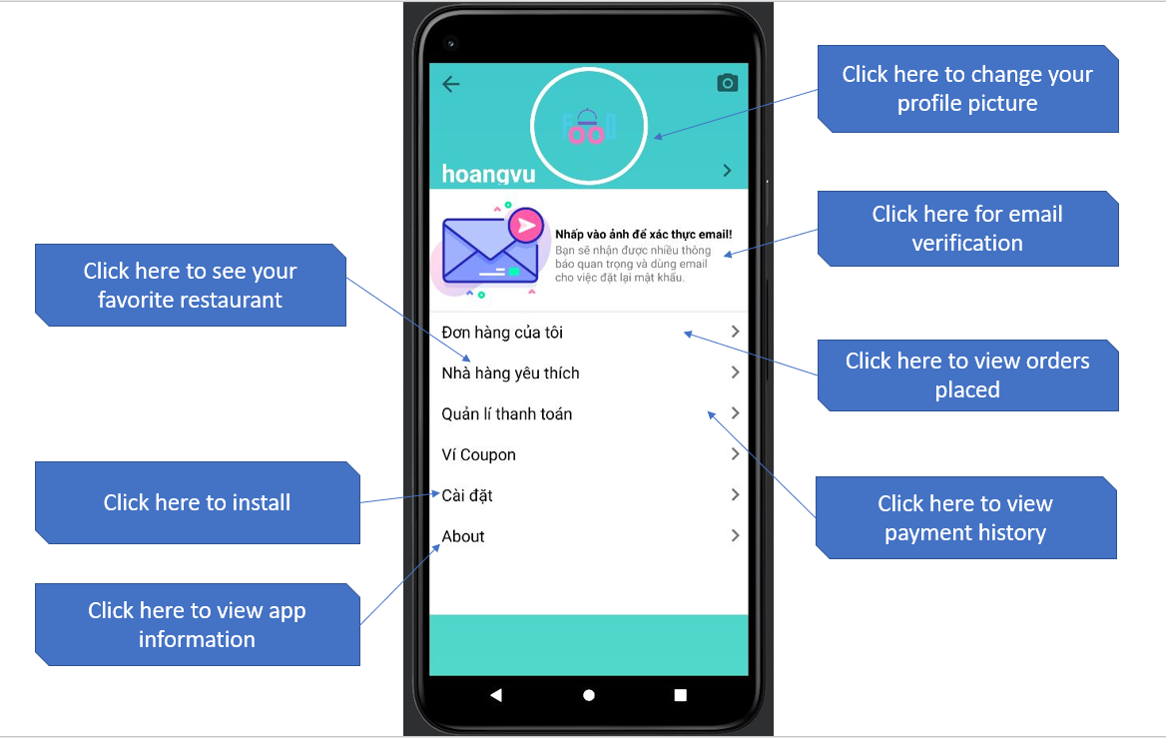

* Email authentication interface:

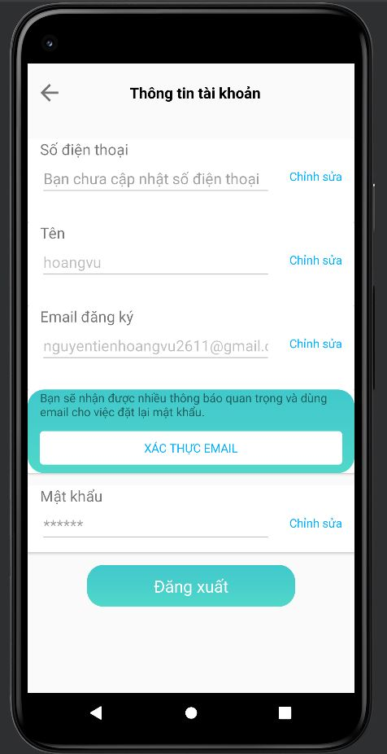

*Email authentication*

* Install interface:

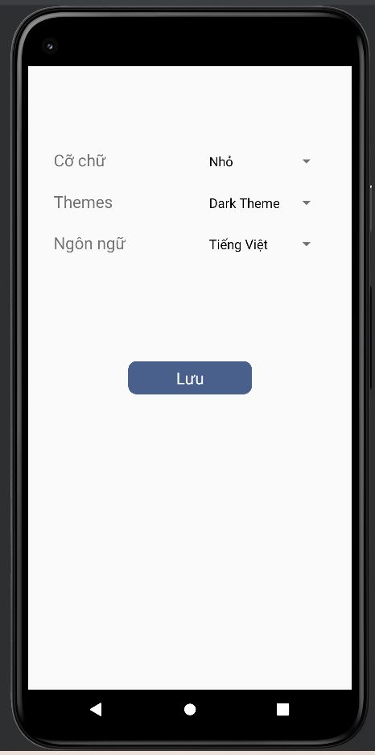

*Install*

* About interface:

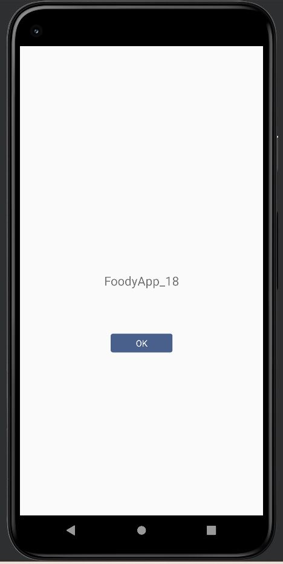

# **CONCLUSION**

1. **Achievements:**

* Built a app: Foody app.
* We can use Layout, Event Handling, List view, SQLite, Fragment, Tab Layout, View Pager.

1. **Advantages:**

* Complete the assigned schedule.
* Try to stick to the set criteria.

1. **Inadequacies:**

* The system only solves the basic problems.
* There are still a number of unresolved issues.

1. **General harvest:**

* Apply knowledge of Mobile Programming to project planning.
* Through this project, we have somewhat understood the most basic concepts and tasks to build a app. At the same time, we have understood and applied more about: Layout, Event Handling, List view, SQLite, Fragment, Tab Layout, View Pager,…
* Perfect the app, easier for the user.

## **Task Distribution**

|  |  |  |  |  |
| --- | --- | --- | --- | --- |
| Task | Taken by | Requirement/purpose | % Done | Result |
| Writing Programs | Trương Hoàng Ân | Foody App | 100% | Done |
| Solve problem and Write Report | Nguyễn Tiến Hoàng Vũ | Foody App | 100% | Done |